T.I. ULANOVA , A.P. OBRIADINA , G. TALEKAR , A.N. BURKOV , H.A. FIELDS ,
Y.E. KHUDYAKOV

RPC Diagnostic Systems, Nizhniy, Novgorod, Russia;
Centers for Disease Control and Prevention, Atlanta, Ga, USA

A NEW ARTIFICAL ANTIGEN OF THE HEPATITIS E VIRUS

Abstract
An artificial antigen composed of 12 small antigenic regions derived from the ORF2 and ORF3 HEV proteins was designed. The gene encoding for this artificial antigen was assembled from synthetic oligonucleotides by a new method called Restriction Enzyme-Assisted Ligation (REAL). The diagnostic relevance of this second generation HEV mosaic protein (HEV MA-II) was demonstrated by testing this antigen against a panel of 142 well defined anti-HEV positive and anti-HEV negative serum samples. The data obtained in this study support the substantial diagnostic potential of this HEV mosaic antigen.
Key words: Artificial antigen, Enzyme immunoassay, Hepatitis E

INTRODUCTION

Hepatitis E was first recognized as enterically-transmitted non-A, non-B hepatitis associated with fecal contamination of drinking water in developing countries.[1] Epidemics of hepatitis E were described in India and many other countries, including Burma, China, the Asian republics of the former Soviet Union and Mexico.[2] Sporadic cases were diagnosed in countries elsewhere in Asia, Northern and Central Africa, and Central and South America. A few sporadic cases diagnosed in North America, Europe, and Australia were associated with individuals who originated from, or had traveled to, regions of known endemicity.[3]
Hepatitis E virus (HEV) genome is a single-stranded polyadenylated RNA of positive polarity which contains three open reading frames (ORF’s).[4] ORF1 of about 5 kb encodes the HEV nonstructural proteins involved in viral genome replication and viral protein processing. ORF2 of about 2 kb encodes the viral capsid protein. A third minor ORF3 encoding a 123 aa protein overlaps the two major ORFs. The encoded protein contains a signal sequence near its N-terminus, but lacks other identifiable motifs.[5]
Based on virion morphology and genome organization, HEV was originally classified as a member of the family Caliciviridae. However, computer-assisted analysis of the HEV ORF1 and the corresponding ORFs of other viruses found no homology with Caliciviruses or other picorna-like viruses.[6–8] Recently, HEV was removed from the family Caliciviridae and has been placed in its own taxonomic group within the class IV (+) sense RNA viruses, ‘‘Hepatitis E-like viruses.’’[9]
The HEV genome is rather heterogeneous. Based on sequence analysis, several HEV isolates identified worldwide have been classified into four genotypes and nine groups.[10] Different HEV genotypes are endemic in different regions of the world, e.g., genotype 1 in Burma, India and Central Asia, genotype 2 in Mexico and genotype 4 in China. There are several reports on indigenous circulation of HEV genotype 3 in regions of the world previously considered free of HEV.[11–13]
Despite sequence heterogeneity, no significant serological differences were found between different HEV strains. All diagnostic tests based on recombinant HEV antigens or synthetic peptides [14–23] from ORF2 can detect anti-HEV activity in serum samples from patients infected with different HEV strains. Only the C-terminal region of the ORF3-encoded protein demonstrated strain-specific antigenic reactivity.[24] This region demonstrated a very complex antigenic structure and contains a number of epitopes. This finding led to the use of both the Burmese and Mexico variants of the ORF3 protein for designing a new diagnostic recombinant protein.[17,25]
Recombinant diagnostic HEV antigens have been constructed using two different strategies. One strategy was based on using full size [26] or fragments of HEV proteins.[27] The other strategy was based on constructing an artificial antigen composed of short antigenic regions with
known diagnostically relevant properties.[28]
The second strategy relies on the identification of antigenic epitopes with synthetic peptides. A number of antigenic epitopes has been identified within the HEV capsid and ORF3 encoded proteins.[24,25,29,30–36] The use of selected small antigenic regions for the construction of diagnostic antigens allows for excluding protein regions showing nonspecific immunoreactivity.[21,28,37] Since nonspecific antigenic epitopes may significantly reduce the specificity of diagnostic assays, the second strategy for constructing antigenic targets from selected diagnostically relevant regions of viral proteins appears to have significant advantages over the first strategy using whole antigens or large fragments of these antigens.[37]
The HEV artificial mosaic antigen[32] constructed using the second strategy from short antigenic regions of the HEV ORF2- and ORF3-encoded proteins has been used to develop assay for the detection of antibody to HEV in serum specimens.[16] However, this antigen was designed using limited information on the localization and property of antigenic epitopes available at that time and was found to be less immunoreactive with serum specimens obtained from convalescent patients (personal observation).
The present study describes the construction and properties of a new diagnostic mosaic antigen (HEV MA-II) designed using the latest data on fine mapping of antigenic epitopes within the HEV ORF2 protein.[33] The results obtained in the course of this research strongly suggest that the HEV MA-II is a potent diagnostic reagent and can be used as a diagnostic target for the development of highly efficient prototype diagnostic assays for the specific and sensitive detection of anti-HEV activity in serum samples.

EXPERIMENTAL

HEV Sequences
Amino acid sequences at position 31–60, 39–64, 85–114, 95–119, 398–427, 403–432, 614–638, 626–655, 631–660, 636–660 of the ORF2 protein of the HEV Burmese strain [33] and at position 91–123 from ORF 3 protein of the Burmese and Mexico strains [32] were reverse translated into DNA by using the optimal E. coli codons. These nucleotide sequences were used to design synthetic oligonucleotides. Twelve overlapping oligonucleotides were designed for assembling the artificial mosaic protein HEV MA-II by Restriction Enzyme Assisted Ligation (REAL).[38]

Assembly of the HEV MA-II Gene
The nucleotide sequence of the HEV MA-II (Fig. 1) was divided into 4 segments, with
2 segments encoding for 4 antigenic regions each and the other 2 segments encoding for
2 antigenic regions each. Twelve overlapping oligodeoxynucleotides of about 90–100 nt each were designed to span the entire HEV MA-II gene.
The synthetic gene was assembled by REAL as described earlier (38) from these 4 segments. Briefly, 2 segments (1 and 2) were assembled from 4 oligonucleotides and another two segments
(3 and 4) were assembled from 2 oligonucleotides that had complementary sequence at the
3′ ends. 50 pmol of each oligonucleotide was used for gene assembly. Each segment was designed in such a way that when oligonucleotides were annealed by its 3′-end complementary sequences, they could be converted into double-stranded DNA by Klenow polymerase. Then each fragment was amplified by PCR using two pairs of primers carrying EcoR1 and BamH1 recognition sites so that each fragment contained EcoR1-site at one end and BamH1-site at the other end. These sites were used for cloning these fragments with a specially designed vector pCV (38). Additionally, each segment contained TAG codon to stop translation at the end of each segment.

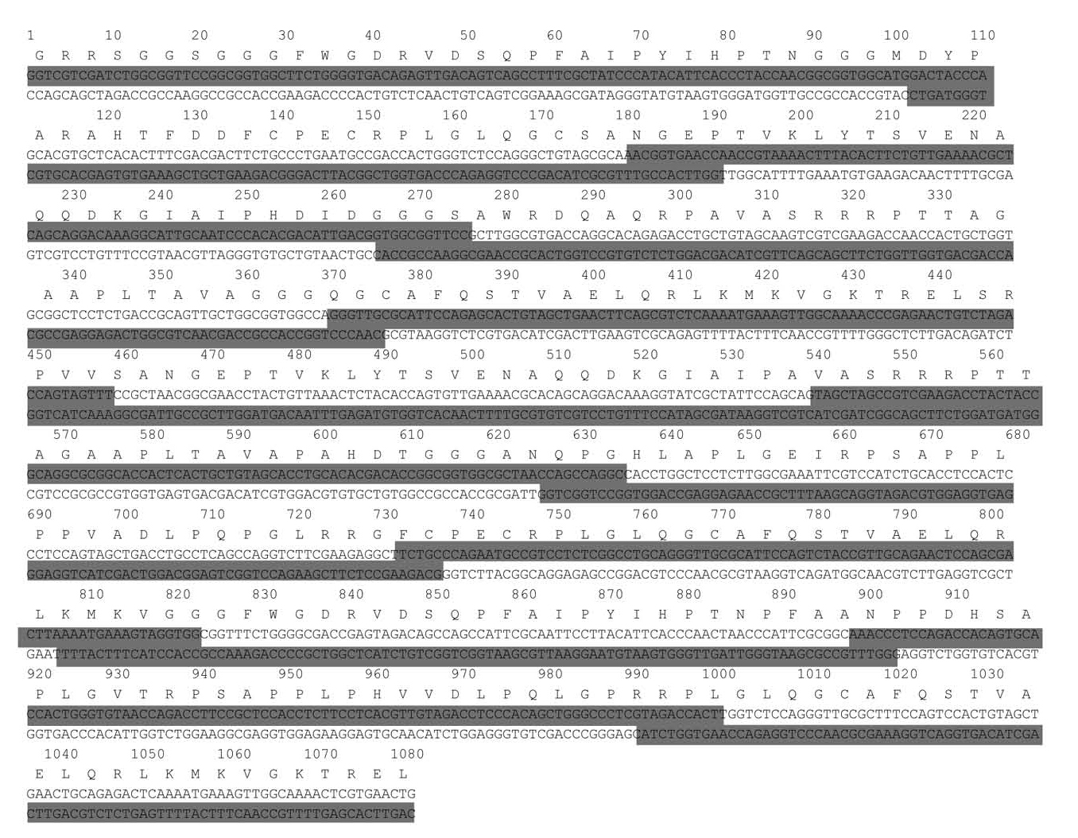

Figure 1. Primary structure of the HEV MA-II gene. Shaded sequences represent synthetic oligonucleotides used for the gene assembly.

After cloning segments with pCV, each segment was flanked with two sets of restriction endonuclease recognition sites. Each fragment was amplified from the recombinant plasmid by using PCR primers derived from the vector sequences flanking the inserts. Then, the PCR
fragments were treated with restriction enzymes and ligated together into dimers, a trimer and a tetramer representing the full-length gene.
This protocol of ligation and cloning of two consecutive DNA fragments was repeated again with each extended fragments until a full-length gene was assembled (Fig. 2).

Gene Expression and Protein Purification
All 4 monomers, 2 dimers, 1 trimer and the full length gene were expressed as fusion proteins with glutathione S-transferase. The transformed E. coli JM109 cells (Promega, Madison, WI) were grown overnight in Luria broth (LB) containing 50 μg/mL of ampicillin at 37°C. The overnight culture was diluted 20 times with fresh LB containing 50 μg/ml ampicillin and grown for 3 to 4 hours until an optical density (OD) reaches 0.6–1.0 at 600 nm. Gene expression was induced by the addition of isopropyl-beta-D-thiogalactopyranoside (IPTG), (Amersham Pharmacia Biotech, Piscataway, NJ) at final concentration of 1mM. The induced cells were continuously grown at 37°C, and harvested 3 hours after the IPTG induction. Cell lysates were prepared according to the published protocol.[39] The glutathione S-transferase fusion proteins were purified by ligand affinity chromatography [40] by using glutathion sepharose 4B column (Amersham Pharmacia Biotech, Piscataway, NJ). The full-length protein was partly insoluble requiring the use of 3M urea and 1% Triton X100 to improve its solubility.

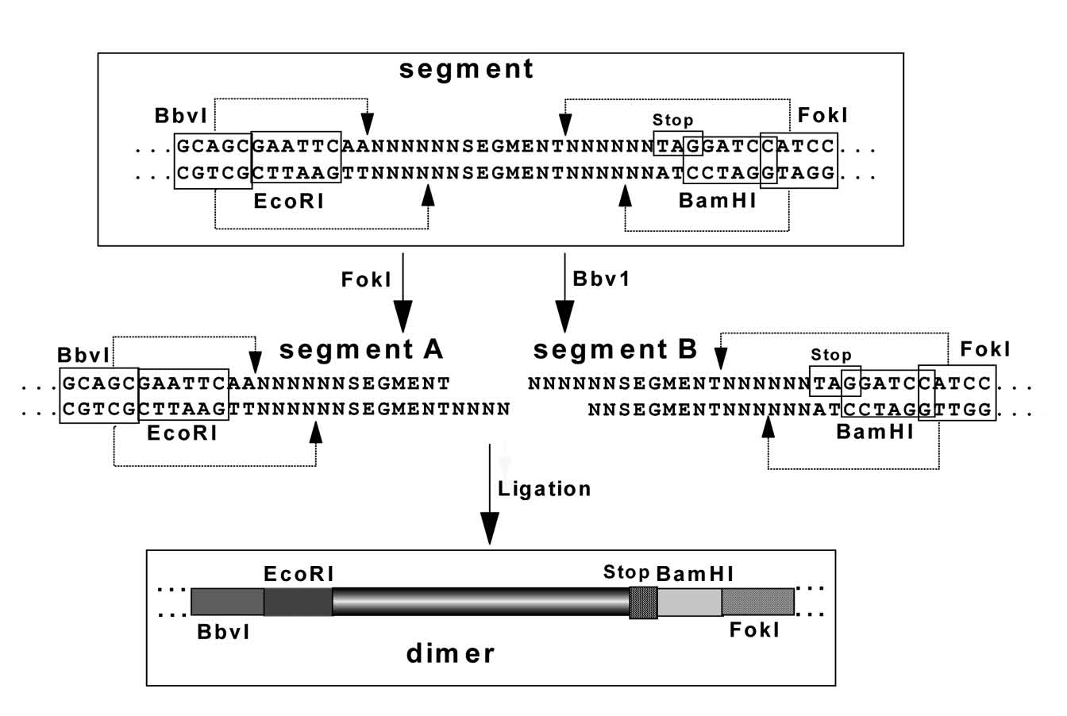

Figure 2. The strategy of Restriction Enzyme Assisted Ligation (REAL).

DNA Sequencing
The primary structure of each individual segment, as well as the dimers, trimer and full-length gene was confirmed by direct DNA sequencing. Sequencing was performed by using an automated sequencer (373DNA sequencer; Applied Biosystems, Foster City, CA) according to the manufacturer’s protocol.

Computer Assisted Sequence Analysis
Amino acid sequence analysis was performed by using the program MegAlign from Lasergene software package (DNASTAR Inc., Madison, WI). Secondary structure of proteins was predicted using a published method.[41]

Synthetic Peptides
Two sets of synthetic peptides were used in this study. Set 1 included synthetic peptides modeling various antigenic epitopes of the HEV ORF2- and ORF3-proteins as previously described.[32,33] Sequences of these peptides were used for HEV MA-II design: peptides 4269 (GRRSGGSGGGFWGDRVDSQPFAIPYIHPTN) and 4342 (GGFWGDRVDSQPFAIPYIHPT NPFA) covers region 31–64 aa; peptides 4274 (SAWRDQAQRPAVASRRRPTTAGAA PLTAVA) and 4350 (PAVASRRRPTTAGAAPLTAVAPAHDT) cover region 85–119 aa; peptide 4307 (SRPVVSANGEPTVKLYTSVENAQQDKGIAIP) and
4308 (SANGEPTVKLYTSVENAQQDKGIAIPHDID) cover region 398–432 aa; peptides
4405 (MDYPARAHTFDDFCPECRPLGLQGC), 4436 (FCPECRPLGLQGCAFQSTVAE LQRLKMK), 4337 (RPLGLQGCAFQSTVAELQRLKMKVGKTREL), 4409 (QGCAFQ STVAELQRLKMKVGKTREL) cover region 614–660 aa of the HEV ORF2
protein Burmese strain (33). Peptide 28 (ANQPGHLAPLGEIRPSAPPLPPVADLPQPGLRR)
and peptide 5 (ANPPDHSAPLGVTRPSAPPLPHVVDLPQLGPRR) are derived from the
C-terminus of the ORF3 protein of the HEV Mexico and Burma strains, consequently.[32]
Set 2 included synthetic peptides derived from different regions of the HEV MA-II (Table 1).

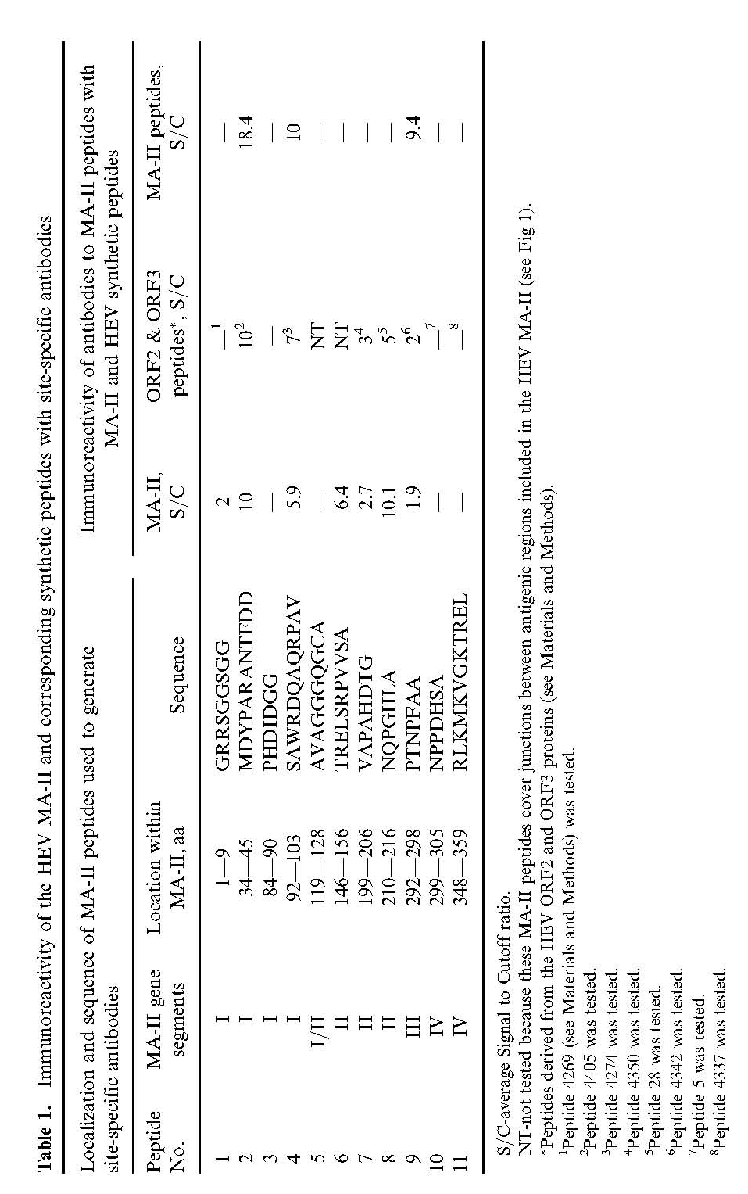

These peptides were used for mice immunization in this study. Both sets were used to study accessibility of different HEV MA-II areas for antibody binding.
Peptides were synthesized by FMOC chemistry[42] on an ACT model MPS 250 multiple peptide synthesizer (Advanced Chemtech, Louisville, KY) according to the manufacturer’s protocols and analyzed by amino acid analysis, high performance liquid chromatography, and capillary electrophoresis.

Mouse Immunization with Synthetic Peptides
Synthetic peptides (2 mg) from set 2 were conjugated with BSA (2 mg) by 1-ethyl-3-
(3-dimethylaminopropyl) carbodiimide hydrochloride (EDC) coupling method using a commercially available kit (Pierce, Rockford, IL). The adjuvant, TiterMax (CytRx, Atlanta, GA), was mixed with conjugated peptides [43] before inoculation. Mice were inoculated subcutaneously at two sites on their back with 50 ul of the solution containing 25 ug of conjugated peptide per site. With the same mode of immunization, animals were boosted
2 weeks later and bled 4 weeks later.

Serum Samples
A collection of 142 serum samples obtained from different parts of the world was used for the evaluation of the full length protein and its intermediated products. Seventy-three sera from patients with acute HEV infection and 10 from the convalescent-phase of infection were obtained from a collection reposited at the Division of Viral Hepatitis, Centers for Disease Control and Prevention (Atlanta, GA). Specimens were collected from patients residing in China, Mexico, India and Mexico. For evaluation of specificity, 59 serum samples obtained from healthy blood donors residing in the United States were used. The anti-HEV status of all specimens was confirmed using 2 commercially available assays (Abbott HEV EIA, Abbott Diagnostic Division, USA; and HEV ELISA, GenlabsTM Diagnostics, Singapore) and testing with previously described synthetic peptides (n=71) modeling various antigenic epitopes derived from the HEV ORF2- and ORF3-proteins.[32,33]

Enzyme Immunoassay (EIA)
Microtiter plates (Nalge Nunc International, Rochester, NY) were sensitized with the optimal amount of protein (20–60μg/mL) determined by checkerboard titration to yield a high positive to negative optical density ratio using positive and negative control sera. Serum samples were
diluted 1:300 in blocking solution (0.1 M phosphate-buffered saline containing 1% bovine serum albumin (BSA), 0.5% Tween 20, and 10% normal goat serum) and incubated in the microtiter wells with preadsorbed recombinant proteins (full-length HEV MA-II and its intermediates) or
synthetic peptides for 1hr at 37°C. After the microtiter wells were washed, 100 μL of goat anti-human immunoglobulin G (IgG) conjugated with horseradish peroxidase diluted 1:10,000 (KPL, Inc., Gaithersburg, Md.) in blocking solution was added to the wells and incubated for 30 min
at 37°C. The microtiter wells were washed again and then subjected to color development by adding o-phenylenediamine according to the manufacture’s protocol (Abbott Laboratories, North Chicago, IL). The reaction was stopped with 50 μL 2N sulfuric acid. The OD of the reaction
was measured at 492 nm. The proteins reactivity were evaluated by calculating a signal/cutoff (S/C) value, where S is the OD value of positive serum samples, and C is cutoff value equal to the mean average OD of a negative control serum samples plus 3.5 standard deviation of the
mean.

RESULTS AND DISCUSSION

Design and Assembly of Mosaic Gene by REAL
The HEV MA-II described in this paper (Fig. 3) included strong antigenic epitopes that were efficiently modeled using 30-mer synthetic peptides located at positions 31–60 aa, 85–114 aa, 398–427 aa, 403–432 aa, 626–655 aa and 631–660 aa and with 25-mer synthetic peptides located
at position 39–64 aa, 95–119 aa, 614–638 aa and 636–660 aa.[33]
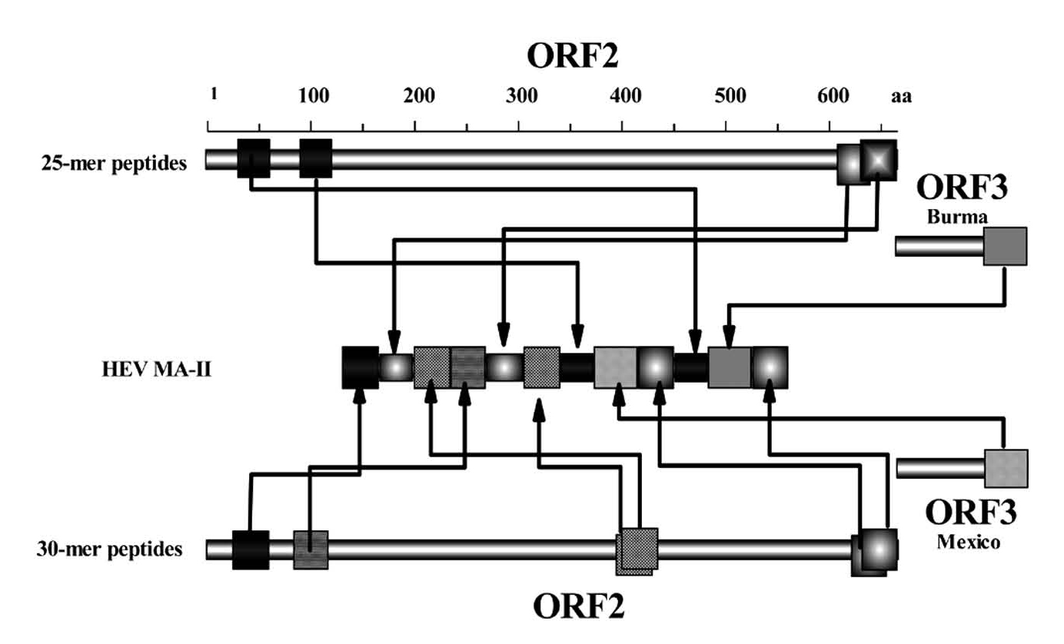

Figure 3. Composition of the HEV MA-II.

Since the antigenic properties of each region were efficiently modeled with synthetic peptides of the defined length these regions were designed to be of the same length as the corresponding peptides and were used as individual entities for designing the artificial antigen instead of using
larger regions comprising overlapping immunoreactive regions modeled with overlapping synthetic peptides.[33] For example, instead of one large region of the HEV ORF2 protein at position 394–470 aa that contains many antigenic epitopes [25,33] and that was designed into the HEV MA-I [23] the HEV MA-II was designed to contain 2 short regions from the HEV ORF2 protein at position 398–427 aa and 403–432 aa, antigenic properties of which were efficiently modeled with overlapping 30-mer synthetic peptides.[33] Similarly, strong antigenic epitopes of the N- and C-terminal regions of the HEV ORF2 protein[25,33] were designed into the HEV MA-II as 4 short regions derived from positions 31–60 aa, 39–63 aa, 85–114 aa and 95–119 aa and 4 short regions derived from positions 614–638 aa, 626–655 aa, 631–660 aa and 636–660 aa of the HEV ORF2 protein, antigenic properties of each were shown to be efficiently modeled with overlapping synthetic peptides of different sizes.[33] As was demonstrated using overlapping synthetic peptides, these antigenic regions despite their significant overlap display slightly different patterns of immunoreactivity with anti-HEV positive serum specimens.[33]
The application of overlapping antigenic regions has an additional potential advantage in increasing avidity binding of antibodies by increasing the epitope density in the HEV MA-II. A similar increase in density of epitopes derived from the influenza virus M2 protein resulted
in higher avidity of M2-specific antibody binding by an artificial protein.[44]
The overlapping regions were, though, designed not to be consecutively arranged within the artificial antigen but to be separated by at least 2 other antigenic regions. The rationale for this arrangement of antigenic regions was that the antibody bound to one site within the HEV MA-II
would not significantly interfere with antibody binding to the other site derived from the same region of the HEV protein. Although the overlapping synthetic peptides derived from same HEV antigenic region displayed somewhat different antigenic properties, they still demonstrated
significantly similar immunoreactivity patterns with anti-HEV-positive serum specimens, which is indicative of shared antigenic epitopes.[33] Therefore, this design of the HEV MA-II from repeats, though not complete repeats, of antigenic regions potentially allows for the duplication of shared antigenic properties while maintaining any additional immunoreactivity, which is specific for each region. Such design ensures that each molecule of the HEV MA-II may bind the HEV antibody by at least 2 antigenic regions, provided that the HEV antibody to at least one overlapping region built into this protein is available in serum specimens. This feature was expected to contribute into a more reliable detection of the HEV antibody by the HEV MA-II than by any other protein containing no duplicated antigenic regions or containing such regions consecutively arranged.
Previously, adding epitopes from ORF3 encoded protein was shown to significantly increase the sensitivity of diagnostic tests.[7,16,32] Synthetic peptides derived from the ORF3 protein of the HEV Mexican or Burmese strains demonstrated different patterns of immunoreactivity
with sera obtained from an HEV outbreak in Mexico compared to sera obtained from Turkmenistan or Kenya.[24,45] The region at amino acid position 91 to 123 of the HEV protein encoded by ORF3 has a very complex antigenic structure. This region contains a number of epitopes that may be affected by sequence heterogeneity of different sequence variants of the HEV ORF3 antigen.[32]
An additional parameter, which was taken into consideration for designing the HEV MA-II, was the predicted protein secondary structure (see Experimental) for the entire HEV ORF2- and ORF3-encoded proteins and for individual antigenic regions. The structure of the antigenic
regions within these proteins was compared to the predicted structure for same regions within the HEV MA-II. These structures were often similar or identical. However, in those cases when the structure was significantly different between the HEV proteins and HEV MA-II, 1 to 3 glycine residues (‘‘folding breakers’’) were inserted between antigenic regions to diminish the effect of adjacent domains on secondary structure of each other (Fig. 4). In all cases, the introduction of these additional glycines improved predicted similarity between HEV proteins and corresponding regions within the HEV MA-II.
The full length HEV MA-II contains 268 aa. The primary structure of this protein was reverse translated into DNA using the optimal E. coli codons. After the addition of a stop codon the resulted DNA sequence of the HEV MA-II gene was composed of 1077 nucleotides.
The resulting sequence was divided into 4 segments. After all four segments were cloned each fragment was amplified from the recombinant plasmid by using PCR primers derived from the vector sequences flanking the inserts. Then, the PCR fragments were treated with restriction
enzymes and ligated together into dimers, a trimer and a tetramer representing the full-length gene (see Experimental, Figs. 2–3). The primary structure of each individual segment, as well as the dimers, trimer and full-length gene was confirmed by direct DNA sequencing. All 4 monomers, 2 dimers, 1 trimer and the full length gene were expressed as fusion proteins with glutathione S-transferase and purified by ligand affinity chromatography (see Experimental). The full-length protein was partly insoluble requiring the use of 3M urea and 1% Triton X100 to improve its solubility.
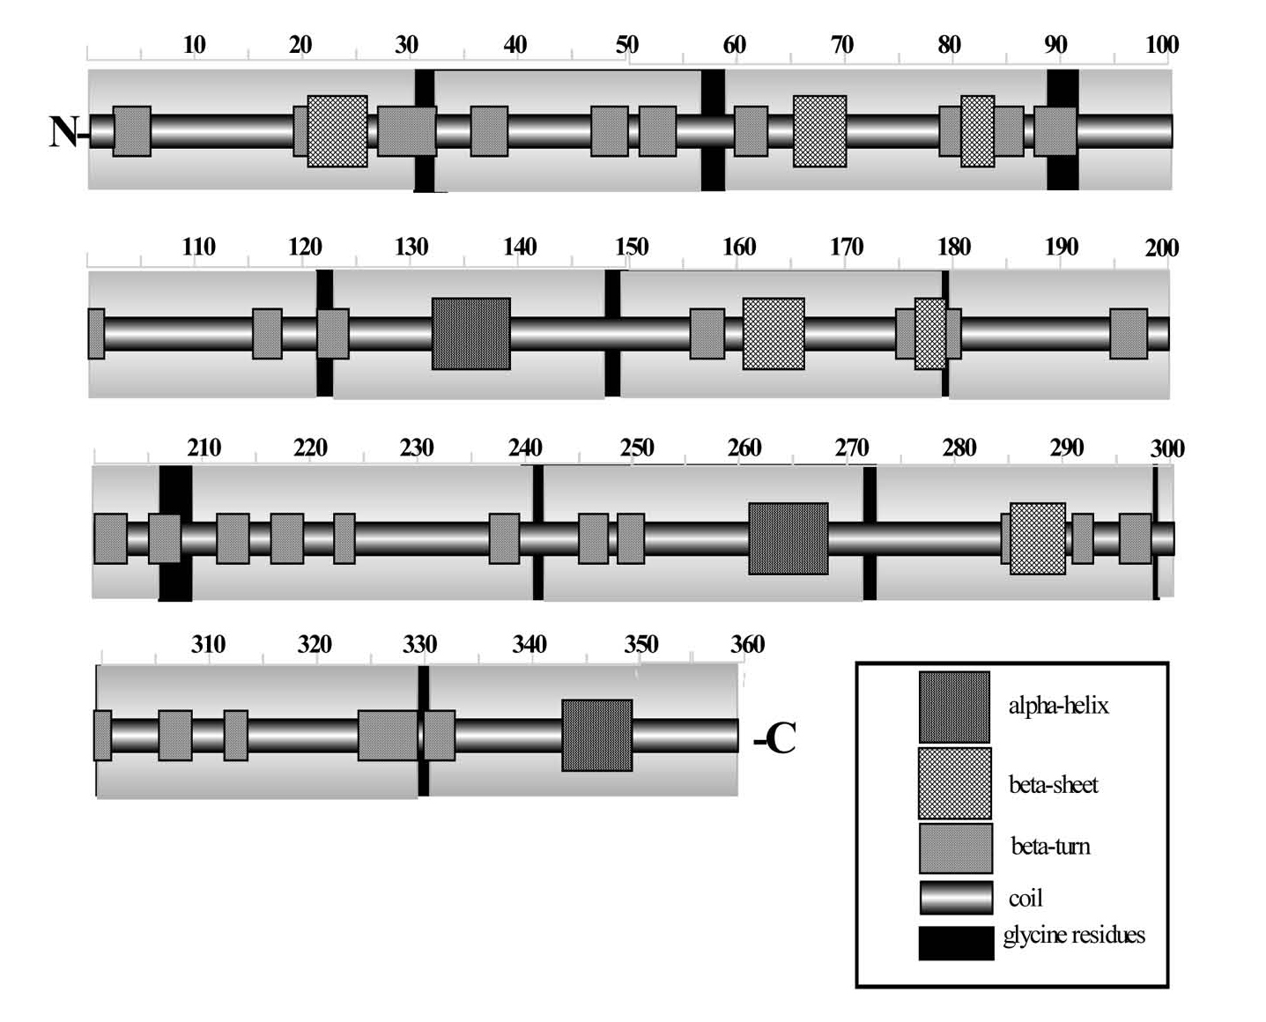
Figure 4. Predicted secondary structure for HEV MA-II.
Accessibility of Different HEV MA-II Regions to Antibody Binding
To assess whether the antigenic epitopes engineered into the HEV MA-II are accessible for immunoreacting with antibodies, sequence-specific antisera were prepared that can recognize at least some of the individual antigenic regions. Accordingly, eleven short synthetic peptides corresponding to different location within HEV MA-II were designed and synthesized
(Table 1). These peptides were conjugated to BSA and used to immunize mice (see Experimental).
Sequence-specific anti-sera were tested with full-length HEV MA-II, with synthetic peptides used for HEV MA-II design and with synthetic peptides homologous to different regions of HEV MA-II (nј11) used for immunization.
Sera obtained against peptides 1, 2, 4, 6, 7, 8, and 9 homologous to different regions of HEV MA-II demonstrated moderate to strong immunoreactivity with the HEV MA-II. The results of this experiment demonstrated that these antigenic regions are exposed on the surface of the
protein molecule and accessible for antibody binding (Table 1). Sera obtained against peptides 3, 5, 10, and 11 did not demonstrate any immunoreactivity with the HEV MA-II. These sera were also not immunoreactive with the corresponding ORF2 or ORF3 derived synthetic peptides
(Table 1) or the immunogen itself suggesting that the negative result with the HEV MA-II was rather due to the absence of antibody activity than the lack of accessibility. Sera against peptide 5 and 6 were not tested with any ORF2 peptides because this peptide comprises the junction between 2 entities of the HEV MA-II, which cannot be found within the ORF2 peptides.
The specificity of anti-peptide antibodies was examined using 25- and 30-mer peptides containing sequences related to all of the antigenic regions included in the HEV MA-II (see Experimental). Five mouse sera against the HEV MA-II homologous peptides 2, 4, 7, 8, and 9 (Table 1) demonstrated strict sequence specific immunoreactivity with corresponding
ORF2 and ORF3 derived peptides.
Sequence-specific anti-serum #8 (Table 1) was found to be two times more immunoreactive with the HEV MA-II than with the MA-II homolog peptide, while serum #1 (Table 1) was found immunoreactive only with the HEV MA-II. These observations suggest that the non-conjugated
peptides 1 and 8 as well as corresponding 25- and 30-mer peptides do not efficiently reproduce antigenic epitopes generated by the conjugated peptides, whereas the HEV MA-II assumes conformation, which efficiently immunoreact with antibodies against conjugated peptides 1
and 8.
Immunoreactivity with Human Serum Specimens
Specificity of HEV MA-II and its intermediate products was evaluated by testing with anti-HEV negative sera samples (n=59). All tested proteins demonstrated 100% specificity. Specific immunoreactivity of the HEV MA-II with human anti-HEV antibodies was studied using 73 serum samples obtained from patients with acute HEV infection, 10 serum samples from the convalescent-phase, and 59 serum samples from healthy blood donors. All serum samples were previously tested by two commercially available assays (see Experimental). Additionally, all serum samples were tested against a set of 71 overlapping 25- and 30-mers synthetic peptides spanning the entire ORF2 protein (33) and the C-terminus of the ORF3 encoded protein (24). Sixty seven out of 73 serum samples from patients with acute disease and 9 of 10 sera from the convalescent-phase were found to be immunoreactive with different synthetic peptides.
These data confirmed that these serum specimens contain antibodies specific to HEV proteins as previously published.[46]
The full-length HEV MA-II and all intermediate products (four segments, two dimers and one trimer) demonstrated variable immunoreactivity as shown in Table 2. Some sera demonstrated immunoreactivity with recombinant proteins without any immunoreactivity against corresponding synthetic peptides. The most immunoreactive protein was the full-length HEV MA-II. This protein detected anti-HEV IgG activity in 70 out of 73 acute-phase sera. Sixty six specimens were detected positive simultaneously with synthetic peptides and this recombinant protein. Four specimens were tested negative with synthetic peptides but positive with the HEV MA-II (Table 2).

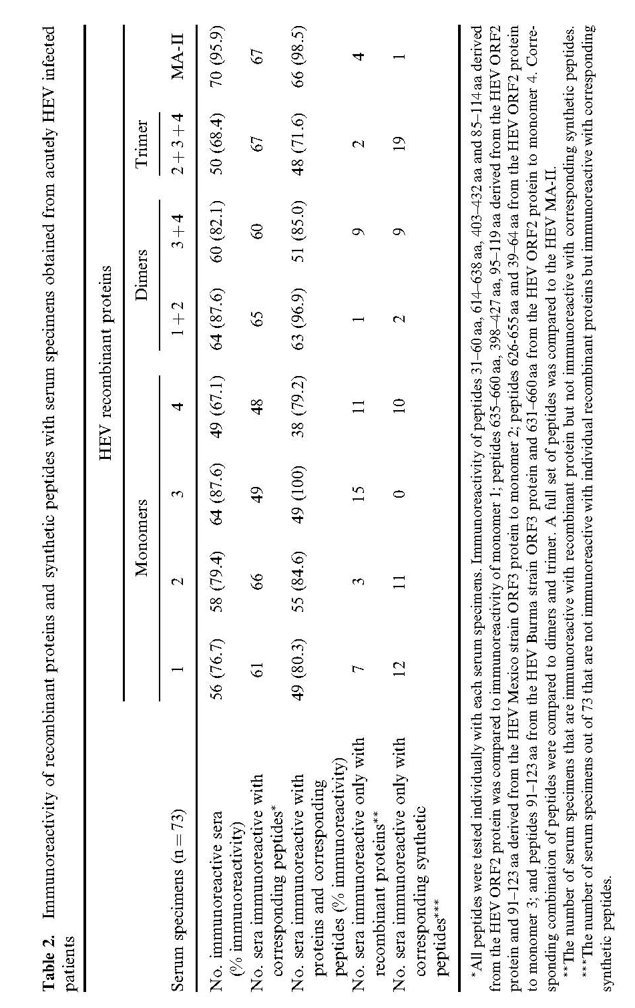

Although the full-size HEV MA-II is the most immunoreactive antigen, the segment 3 was found immunoreactive with 87.6% of acute-phase sera and, therefore, is almost as immunoreactive as the full-size antigen (Table 2). However, corresponding synthetic peptides immunoreacted collectively with only 49 sera (Table 2). On the other hand, the most collective immunoreactivity was observed for synthetic peptides corresponding to the segment 2. These peptides can detect antibody in 66 of acute-phase serum specimens, whereas the recombinant segment 2 detects antibodies in only 58 sera (Table 2).
Six serum samples from patients with acute HEV infection were found not to be immunoreactive with any of the 71 overlapping synthetic peptide (Table 3); however, three of them were immunoreactive with the full-length HEV MA-II and intermediate products of the HEV MA-II.
All recombinant proteins used in this study were capable of detecting anti-HEV activity in some serum samples that were non-immunoreactive with the corresponding synthetic peptides (Tables 2 and 3). For example, segment 3 that contains two strongly immunoreactive epitopes located at
the N- and C-terminus of the ORF2 encoded protein detected anti-HEV activity in all serum samples which were positive with the corresponding synthetic peptides (Table 2) and additionally this protein detected antibody in 15 serum samples that were non-reactive with these peptides (Table 2).
Nine out of 73 acute-phase anti-HEV positive serum samples were immunoreactive only with synthetic peptides derived from ORF3 encoded protein. Peptides derived from ORF3 protein of the Burmese and Mexican strains detected anti-HEV activity in 4 and 8 sera, respectively, from these 9 samples. All recombinant antigens also were variably immunoreactive with these serum samples. The full-length HEV MA-II detected antibody activity in 8 out of 9 samples. The dimer containing the epitope from the Mexican strain also detected activity in 8 samples. The segment (monomer) including the same epitope detected activity in only 4 samples. Interestingly,
the segment including this epitope from the Burmese strain detected anti-HEV activity in 7 sera out of 9, while the corresponding synthetic peptide detected anti-HEV activity in only 4 sera.

Table 3. Immunoreactivity of the recombinant HEV proteins with anti-HEV positive sera
non reactive with synthetic peptides, sequences of which were used for the HEV MA-II design

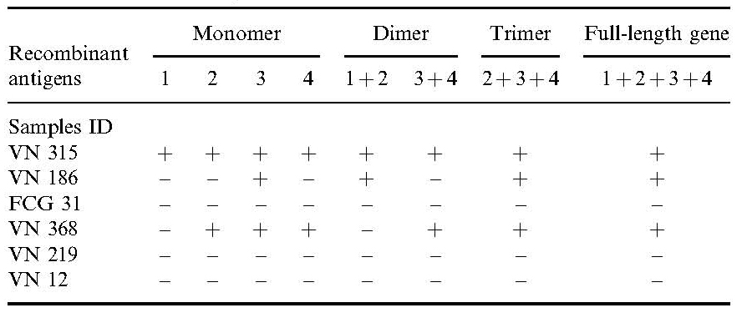

Six serum samples were positive with only synthetic peptides derived from the 626–660 aa sequence of ORF2 encoded protein.The synthetic peptide containing the 626–656 aa sequence detected only 1 of 6 serum samples, while the synthetic peptide containing the 631–660 aa sequence detected anti-HEV activity in all 6 sample. The full-length MA-II and the segment
# 4 containing 631–660 aa sequence also detected all 6 sera. However, the dimer and trimer that contain this sequence detected only 5 and 2 serum specimens, respectively.
The data demonstrate that there is no tight relationship between immunoreactivity of recombinant antigens and corresponding synthetic peptides. The presentation of antigenic epitopes by synthetic peptides and recombinant antigens may differ. The other interesting observation is that when all 12 synthetic peptides were mixed together and used for the detection of anti-HEV activity in same serum specimens, only 49.3% of these sera showed immunoreactivity.
This data support previous observations made using a large set of recombinant polypeptides containing different parts of the HEV ORF 2 protein. It has been shown that the antigenic properties of some fragments of this protein differed from the antigenic properties of the whole
protein.[27] Also, as has been previously reported the reactivity of ORF2 encoded fragments expressed in E. coli is dependent on the length of the protein.[27,34,47,48] These findings suggest that the antigenic composition of the HEV ORF 2 encoded protein is complex and that different antigenic epitopes can be efficiently modeled with different fragments of this protein as represented with either synthetic peptides or recombinant proteins.The data obtained in the present study provide an additional support to this observation and demonstrate that different patterns of immunoreactivity are associated with antigenic epitopes presented with synthetic peptides or arranged into artificial recombinant antigens.
Nine out of ten convalescent-phase samples contain anti-HEV activity that can be detected using synthetic peptides. All intermediate products and the full-length HEV MA-II also were immunoreactive with some of these sera. The most immunoreactive proteins were the dimer
containing segments 1 and 2 and the full-length HEV MA-II immunoreacting with 8 and 9 specimens, respectively. One convalescent specimens tested negative against all peptides and recombinant proteins.

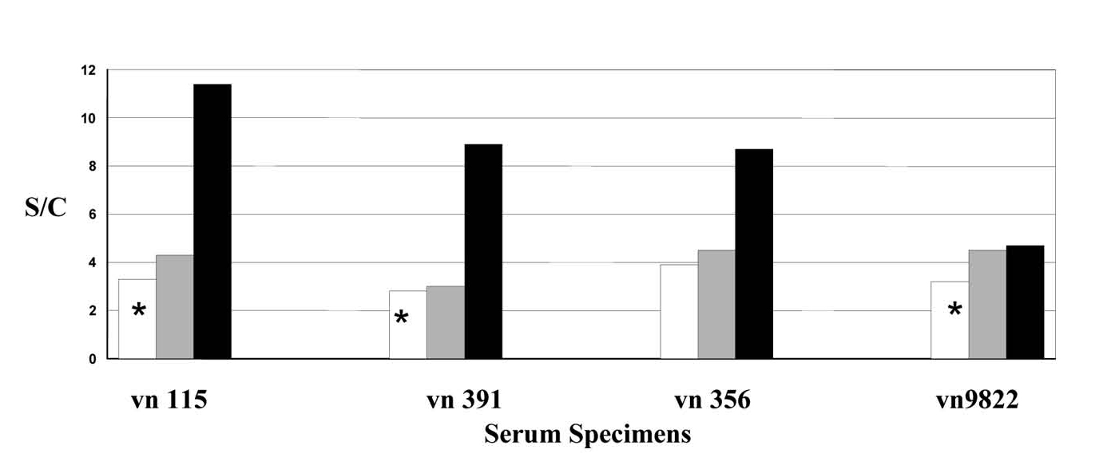

Figure 5. Immunoreactivity of recombinant proteins with serum specimens immunoreactive with only one synthetic peptide: hollow bar with an asterisk–S/C value for peptide comprising sequence at position 91–103 aa of the HEV Mexico strain ORF3 protein; hollow bar without an asterisk–S/C value for peptide containing sequence 403–432 aa of the HEV Burma strain ORF2 protein; shaded bar–S/C value for the monomer containing sequence of the corresponding HEV ORF2 or ORF3 peptide; and black
bar–S/C value for the HEV MA-II.

Four serum samples were immunoreactive with only one synthetic peptide (Fig. 5). The level of immunoreactivity of the corresponding recombinant antigens and synthetic peptides were compared. In three cases the full-length MA-II demonstrated significantly higher levels of
immunoreactivity.

CONCLUSION
The strategy of artificial antigens composed of small antigenic regions has been previously employed for hepatitis B virus, [49] hepatitis C virus, [21,50] and hepatitis E virus.[28] The mosaic antigen strategy has several advantages. First, it allows for obtaining artificial antigens that contain only antigenic epitopes relevant to immunodiagnostics, while eliminating epitopes that may be involved in nonspecific reactivity. This advantage of the strategy was used to construct the HEV mosaic antigen (HEV MA-I).[28] Second, a single artificial antigen constructed using this strategy may contain antigenic epitopes from different viral roteins [28,50]
and/or from different viral strains.[38] Third, it affords the flexibility of reengineering the position and multiplicity of each antigenic epitope as needed. The present study explores this advantage of the mosaic antigen strategy to re-engineer the HEV MA-I into HEV MA-II.
In this study we developed a single multi-epitope mosaic antigen HEV MA-II. The overall strategy for making this antigen included the use of synthetic peptides to study the antigenic structure of proteins, selection of short sequence variants that model broadly immunoreactive antigenic epitopes, and the construction of a synthetic gene encoding an artificial polypeptide composed of these short antigenically reactive regions.
Besides the addition of recently identified antigenic epitopes,[33] the HEV MA-II was designed using a new principle based on understanding that different parts of the HEV ORF2 protein reproduced with overlapping synthetic peptides (33) or recombinant proteins[27] may model different subsets of antigenic epitopes.
The HEV MA-II was used for the development of sensitive and specific EIA for the detection of anti-HEV activity in serum samples.[46] All these data obtained in the present study as well in some previous works [28,38,49,50] significantly substantiate the concept of artificial diagnostic antigens constructed of several short antigenic regions as the potentially powerful new way of rationale design for diagnostic targets.

REFERENCES
1. Harrison, T.J. Heaptitis E virus an update. Liver 1999, 19, 171–176.
2. Bradley D.W. Hepatitis E: Epidemiology, aetiology and molecular biology. Rev. Med. Virol. 1992, 2, 19–28.
3. Worm, H.C.; Schlauder, G.G.; Brandstatter, G. Hepatitis E and its emergence in non-endemic areas. Wien Klin. Wochenschr. 2002, 114 (15–16), 663–670.
4. Carl, M.; Isaacs, S.N.; Kaur, M.; He, J.; Tam, A.W.; Yarburg, P.O.; Reyes, G.R. Expression of hepatitis E virus putative structural proteins in recombinant vaccinia viruses. Clin. Diagn. Lab. Immunol. 1994, 1, 253–256.
5. Krawczynski, K.; Aggarwal, R.; Kamili, S. Hepatitis, E. Infect. Clin N. Amer. 2000, 14 (3), 669–687.
6. Koonin, E.V.; Gorbalenya, A.E.; Purdy, M.A.; Rozanov, M.N.; Reyes, G.R.; Bradley, D.W. Computer assisted assignment of functional domains in the nonstructural polyprotein of hepatitis E virus: delineation of an additional
group of positive strand RNA plant and animal viruses. Proc. Natl. Acad. Sci. USA 1992, 89, 8259–8263.
7. Lai, S.K.; Tulasiram, P.; Jameel, S. Expression and characterization of the hepatitis E virus ORF 3 protein in the methylotrophic yeast, Pichia pastoris. Gene 1997, 190, 63–67.
8. Kabrane Lazizi, Y.; Meng, X.J.; Purcell, R.H.; Emerson, S.U. Evidence that the genomic RNA of hepatitis E virus capped. J. Virol. 1999, 73, 8848–8850.
9. Berke, T.; Matson, D.O. Reclassification of the Caliciviridae into distinct genera and exclusion of hepatitis E virus from the family on the basis of comparative phylogenetic analysis. Arch. Virol. 2000, 145 (7), 1421–1436.
10. Schlauder, G.G.; Mushahwar, I.K. Genetic heterogeneity of Hepatitis E Virus. J. Med. Virol. 2001, 65, 282–292.
11. Schlauder, G.G.; Desai, S.M.; Zanetti, A.R.; Tassopoulos, N.C.; Mushahwar, I.K. Novel hepatitis E virus (HEV) isolates from Europe: evidence for additional genotypes of HEV. J. Med. Virol. 1999, 57 (3), 243–251.
12. Zanetti, A.R.; Schlauder, G.G.; Romano, L.; Tanzi, E.; Fabris, P.; Dawson, G.J.; Mushahwar, I.K. Identification of a novel variant of hepatitis E virus in Italy. J. Med. Virol. 1999, 57 (4), 356–360.
13. Waar, K.; Herremans, M.M.; Vennema, H.; Koopmans, M.P.; Benne, C.A. Hepatitis E is a cause of unexplained hepatitis in The Netherlands. J. Clin. Virol. 2005, 33 (2), 145–149.
14. Chau, K.H.; Dawson, G.J.; Bile, K.M.; Magnius, L.O.; Sjogren, M.H.; Mushawar, I.K. Detection of IgA class antibody to hepatitis E virus in serum samples frompatientswith hepatitisE infection. J.Med.Virol. 1993, 40, 334–338.
15. Dawson, G.J.; Chau, K.H.; Cabal, C.M.; Yarburg, P.O.; Reyes, G.R.; Mushavar, I.K. Solidphase enzymelinked immunosorbent assay for hepatitis E virus IgG and IgM antibodies utilizing recombinant antigens and synthetic
peptides. J. Virol. Meth. 1992, 38, 175–186.
16. Favorov, M.O.; Khudyakov, Y.E.; Mast, E.E.; Yashina, T.L.; Shapiro, C.N.; Khudyakova, N.S.; Jue, D.L.; Onischenko, G.G.; Margolis, H.S.; Fields, H.A. IgM and IgG antibodies to hepatitis E virus (HEV) detected by an
enzyme im munoassay based on an HEV specific artificial recombinant mosaic protein. J. Med. Virol. 1996, 50, 50–58.
17. Fields, H.A.; Khudyakov, Y.E.; Favorov, M.O.; Khudyakova, N.S.; Cong, M.; Holloway, B.F.; Lambert, S.B.; Jue, L.D. Artificial mosaic proteins as new immunodiagnostic reagents: the hepatitis E virus experience. Clin. Diag.
Virol. 1996, 5, 167–179.
18. Goldsmith, R.; Yarbourg, P.O.; Reyes, G.R.; Fry, K.E.; Gabor, K.A.; Kamel, M.; Zakaria, S.; Amer, S.;
Gaffar, Y. Enzymelinked immunosorbent assay for diagnosis of acute sporadic hepatitis E in Egyptian children. Lancet 1992, 339, 328–331.
19. Lok, A.S.F.; Kwan, W.K.; Moeckli, R.; Yarbourg, P.O.; Chan, R.T.; Reyes, G.R.; Lai, C.L.; Chung, H.T.;
Lai, T.S.T. Seroepodemiological survey of hepa titis E in Hong Kong by recombinantbased enzyme immunoassays.
Lancet 1992, 340, 1205–1208.
20. Mast, E.E.; Alter, M.J.; Holland, P.V.; Purcell, R.H. Evaluation of assays for antibody to hepatitis E virus by a serum panel. Hepatitis E virus antibody serum panel evaluation group. Hepatology 1998, 27, 857–861.
21. Yarbough, P.O.; Garza, E.; Tam, A.W.; Zhang, Y.; McAtee, P.; Fueerest, TR. Assay development of diagnostic tests for IgM and IgG antibody to hepati tis E virus; in Buisson Y.P., Coursaget P., Kane M: Enterically Transmitted
Hepatitis viruses. Joueles Tours, La Simarre 1996, 294–296.
22. Yarburgh, P.O.; Tam, A.W.; Fry, K.E.; Krawczynski, K. Hepatitis E virus: identification of typecomon epitopes. J. Virol. 1991, 5, 5790–5797.
23. Zhang, J.Z.; Stanley, W.K.; Lau, S.H.; Chau, T.N.; Lai, S.T.; Ng, S.P.; Malik, P.C.; Tse Ng, T.K.; Ng, M.H. Occurrence of hepatitis E virus IgM, low avidity IgG serum antibodies, and viremia in sporadic cases of nonA,
B, and C acute hepatitis. J. Med. Virol. 2002, 6, 40–48.
24. Khudyakov, Y.E.; Khudyakova, N.S.; Fields, H.A.; Jue, D.; Starling, C.; Favorov, M.O.; Krawczynski, K.; Polish, L.; Mast, E.; Margolis, H. Epitope mapping in proteins of hepatitis E virus. Virology 1993, 194,
89–96.
25. Khudyakov, Y.E.; Favorov, M.O.; Jue, D.L.; Hine, T.K.; Fields, H.A. Immunodominant antigenic regions in a structural protein of the hepatitis E virus. Virology 1994, 98, 390–393.
26. He, J.; Ching, W.M.; Yarbough, P.; Wang, H.; Carl, M. Purification of a baculovirus-expressed hepatitis E virus structural protein and utility in an enzyme-linked immunosorbent assay. J. Clin. Microbiol. 1995, 12, 3308–
3311.
27. Li, F.; Torresi, J.; Locarnini, S.A.; Zhuang, H.; Zhu, W.; Guo, X.; Anderson, D.A. Aminoterminal epitopes are exposed when fulllength open reading 2 of he patitis E virus is expressed in Escherichia coli, but carboxyterminal
epitopes are masked. J. Med. Virol. 1997, 52, 289–300.
28. Khudyakov, Y.E.; Favorov, M.O.; Khudyakova, N.S.; Gong, M.-E.; Holloway, B.P.; Padhye, N.; Lambert, S.B.; Jue, D.L.; Fields, H.A. Artificial mosaic protein containing antigenic epitopes of hepatitis E virus. J. Virol.
1994, 68 (11), 7067–7074.
29. Cousaget, P.; Buisson, Y.; Depril, N.; Cann, P.; Chabaud, M.; Molinie, C.; Roul, R. Mapping of linear B cell epitopes on open reading frames 2 and 3 encoded proteins of hepatitis E virus using synthetic peptides. FEMS Microbiol. Lett. 1993, 109, 251–255.
30. Ichikawa, M.; Araki, M.; Rikhisa, T.; Uchida, T.; Shikata, T.; Mizuno, K. Cloning and expression of cDNAs from enterically transmitted nonA, nonB hepatitis virus. Microbiol. Immunol. 1991, 35, 535–543.
31. Kaur, M.; Hyams, K.C.; Purdy, M.A.; Krawzchinski, K.; Ching, W.M.; Fry, K.E.; Reyes, G.R.; Bradley, D.W.; Carl, M. Human linear Bcell epitopes encoded by the hepatitis E virus include determinants in the RNA dependent RNA polymerase. Proc. Natl. Acad. Sci. USA 1992, 89, 3855–3858.
32. Khudyakov, Y.E.; Khudyakova, N.S.; Jue, D.L.; Wells, T.W.; Padhya, N.; Fields, H.A. Comparative characterization of antigenic epitopes in the immunodomi nant region of the protein encoded by open reading frame 3 in Burmese and Mexican strains of hepatitis E virus. J. Gen. Virol. 1994, 75 (Pt 3), 641–646.
33. Khudyakov, Y.E.; Lopareva, E.N.; Jue, D.L.; Crews, T.K.; Thygarajan, S.P.; Fields, H.A. Antigenic domains of the open reading frame 2 encoded protein of hepatitis E virus. J. Clin. Microbiol. 1999, 37 (9), 2853–2871.
34. Li, F.; Riddell, M.A.; Seow, H.F.; Takeda, N.; Miyamura, T.; Anderson, D.A. Recombinant subunit ORF2.1 antigen and induction of antibody against immu nodominant epitopes in the hepatitis E virus capsid protein.
J. Med.Virol. 2000, 60, 379–386.
35. Li, F.; Zhuang, H.; Kolivas, S.; Locarnini, S.A.; Anderson, D.A. Persistent and transient antibody responses to hepatitis E virus detected by Western immuno blot using open reading frame 2 and 3 glutation Stransferase fusion
proteins. J. Clin. Microbiol. 1994, 32, 2060–2066.
36. Schofield, D.J.; Glamann, J.; Emerson, S.U.; Purcell, R.H. Identification by phage display and characterization of two neutralizing chimpanzee monoclonal antibodies to the hepatitis E virus capsid protein. J. Virol. 2000, 74
(12), 554–855.
37. Chang J.C. Towards designer diagnostic antigens. In Artificial DNA: Methods and Applications; Khudyakov Y.E, Fields H.A., Eds.; CRC Press: Boca Raton, FL, 2002; 363–384.
38. Chang, J.C.; Ruedinger, B.; Cong, M.; Lambert, S.; Lopareva, E.; Purdy, M.; Holloway, B.P.; Jue, D.L.; Ofenloch, B.; Fields, H.A.; Khudyakov, Y.E. Artificial NS4 mosaic antigen of hepatitis C virus. J. Med. Virol. 1999, 59, 437–450.
39. Sambrook, J.; Fritsch, E.F.; Maniatis, T. Molecular Cloning; Cold Spring Harbor Laboratory Press: New York, 1988.
40. Smith, D.B.; Johnson, K.S. Single step purification of polypeptides expressed in Escherichia coli as fusions with glutathione S transferase. Gene 1988, 67 (1), 31–40.
41. Ptitsyn, O.B.; Finkelstein A.V. Theory of protein secondary structure and algorithm of its prediction. Biopolymers 1983, 22, 15–25.
42. Barany, G.; Merrifield, R.B. Solid-phase Peptide Synthesis. In The Peptides; Gross, E.; Meienhoter, J.; Eds.; Academic Press: New York, 1980; Vol. 1, 1–284.
43. Aichele, P.; Hengartner, H.; Zinkernagel, R.M.; Schulz, M. Antiviral cytotoxic T cell response induced by in vivo priming with a free synthetic peptide. J. Exp. Med. 1990, 171 (5), 1815–1820.
44. Liu, W.; Chen, Y.H. High epitope density in a single protein molecule significantly enhances antigenicity as well as immunogenicity: a novel strategy for modern vaccine development and a preliminary investigation about B cell discrimination of monomeric proteins. Eur. J. Immunol. 2005, 35 (2), 505–514.
45. Irshad, M. Hepatitis E virus: an update on its molecular, clinical and epidemiological characteristics. Intervirology 2000, 42 (4), 252–262.
46. Obriadina, A.; Meng, J.; Ulanova, T.; Trinta, K.; Burkov, A.; Fields, H.; Khudyakov, Y. A new enzyme immunoassay for the detection of antibody to hepatitis E virus. J. Gastroenterol. Hepatol. 2002, 17 (Suppl. 3),
S360–S364.
47. Riddell, M.A.; Li, F.; Anderson, D.A. Identification of immunodominant and conformational epitopes in the capsid protein of hepatitis E virus by using mo noclonal antibodies. J. Virol. 2000, 74 (17), 8011–8017.
48. Zhang, Y.; McAtee, P.; Yarbough, P.O.; Tam, A.W.; Fuerst, T. Expression, characterization, and immunoreactivities of a soluble hepatitis E virus putative capsid protein species expressed in insect cells. Clin. Diag. Lab. Immunol. 1997, 4 (4), 423–428.
49. Kumar, V.; Bansal, V.J.; Rao, K.V.; Jameel, S. Hepatitis B virus envelope epitopes: gene assembly and expression in Escherichia coli of an immunologically reactive novel multiple-epitope polypeptide 1 (MEP-1).
Gene 1992, 110 (2), 137–144.
50. Yagi, S.; Kashiwakuma, T.; Yamaguchi, K.; Chiba, Y.; Ohtsuka, E.; Hasegawa, A. An epitope chimeric antigen for the hepatitis C virus serological screening test. Biol. Pharm. Bull. 1996, 19 (10), 1254–1260.

J. Immunoassay Immunochem. 2009; 30(1):18-39.

